LIBSPACE – LIBRARY MANAGEMENT BACKEND APPLICATION

PROJECT OVERVIEW
LibSpace is a backend web application designed to manage library book records and user authentication. It provides users with a secure and structured system to store, manage, and update book information. The application focuses on secure user authentication, efficient book management, and reliable API communication. By using modern backend technologies such as Node.js, Express.js, and MongoDB, LibSpace offers a scalable backend system for managing library data.

KEY OBJECTIVES
- Provide secure user authentication and account management
- Enable efficient book management through CRUD operations
- Maintain relationship between users and their books
- Protect private routes using JWT authentication
- Deliver scalable backend architecture
- Target Users
- Students managing personal book collections
- Library administrators
- Developers learning backend API development
- Institutions managing digital book records

PROJECT INSTRUCTIONS
Step 1: Install Node.js from https://nodejs.org
Step 2: Create backend project folder and open it in terminal.
Step 3: Initialize Node project
npm init -y
Step 4: Install dependencies
npm install express
npm install mongoose
npm install nodemon --save-dev
Step 5: Create server file
index.js
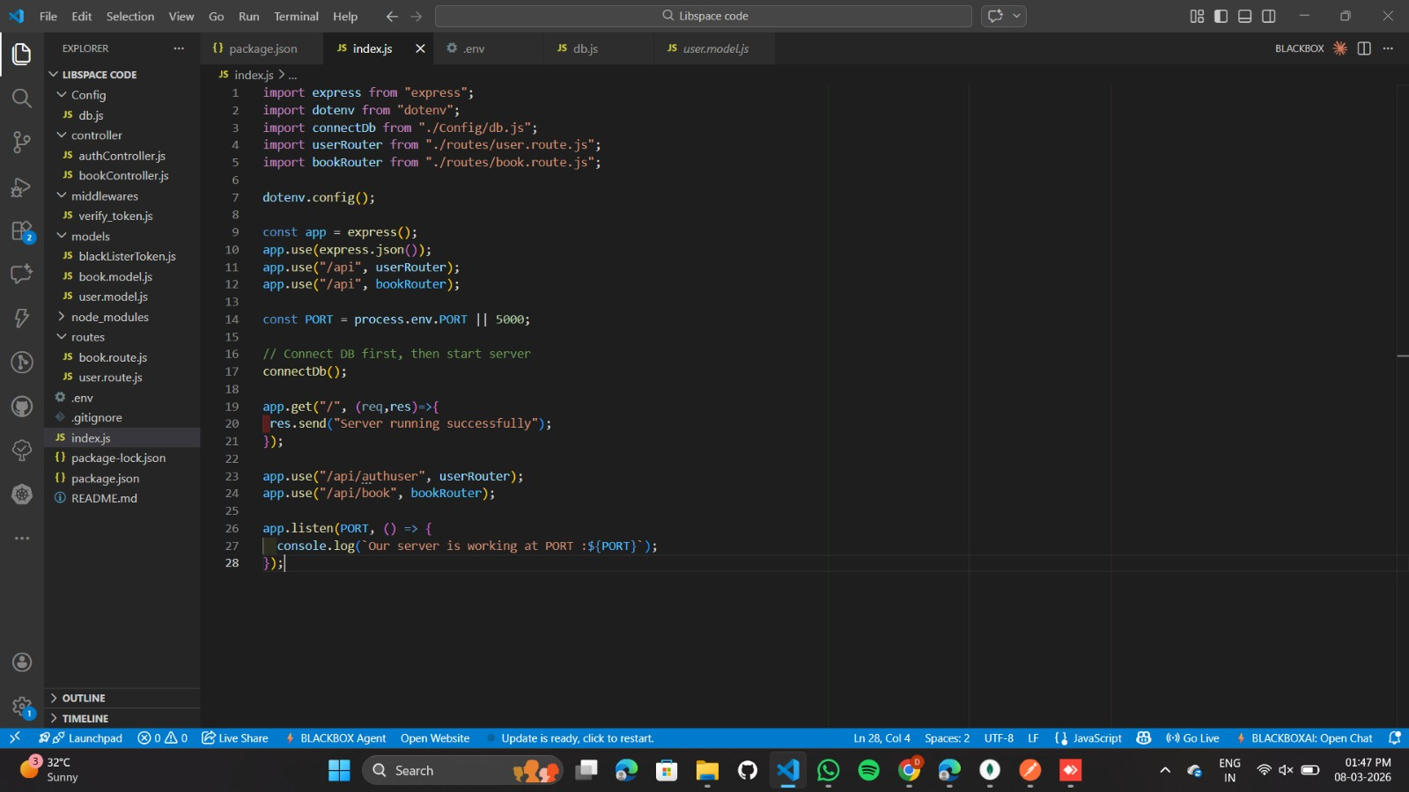

Step 6: Enable ES modules in package.json
"type": "module"
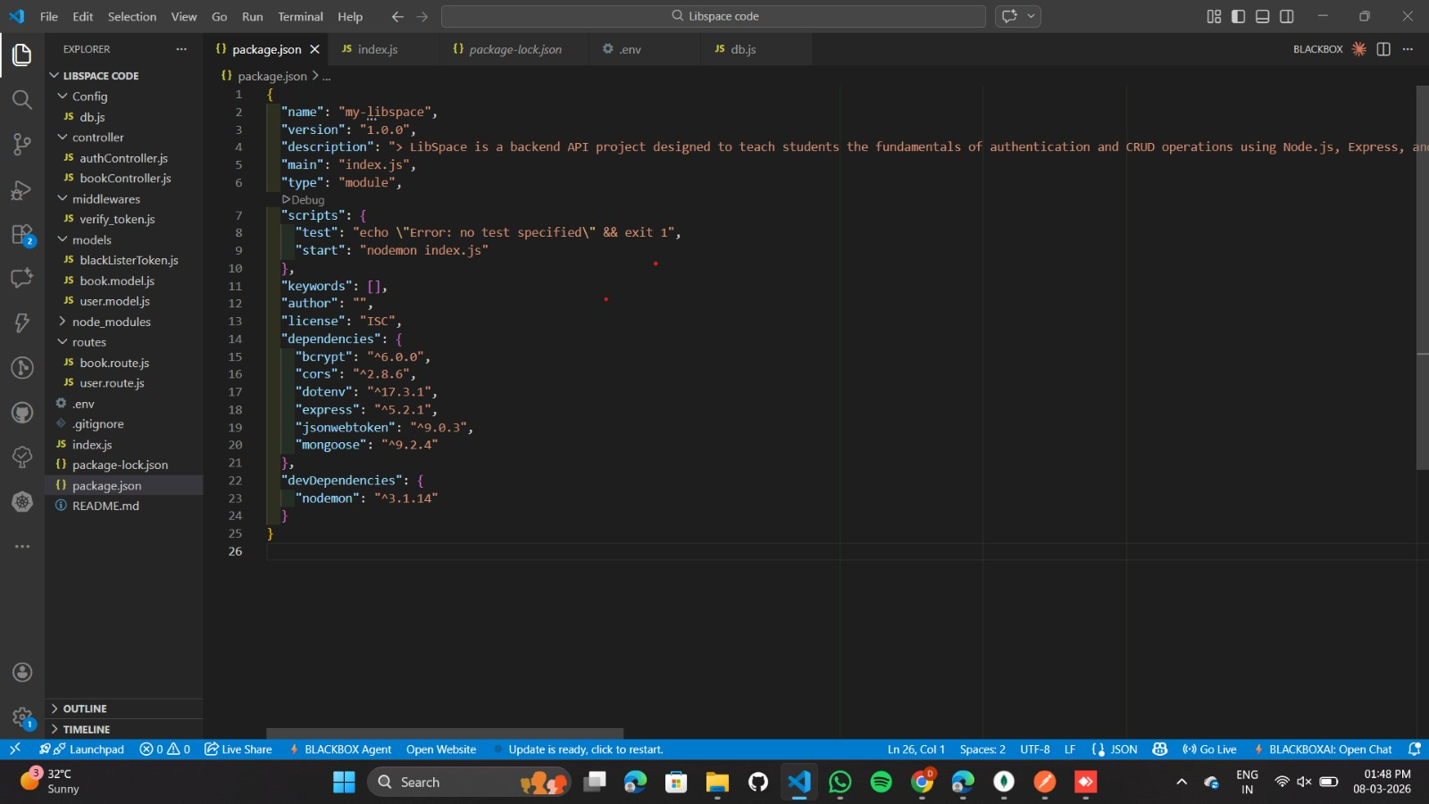
Step 7: Start server
npm run dev
or
node index.js
Step 8: Open in browser
http://localhost:5000

PRE-REQUISITES

Software Requirements
Software | Purpose
Node.js | JavaScript runtime for backend
MongoDB | NoSQL database for data storage
npm | Package manager
Git | Version control
Code Editor | VS Code / WebStorm

Knowledge Requirements
- JavaScript ES6+ syntax and concepts
- Node.js and Express.js for REST API development
- MongoDB and Mongoose ODM
- JWT authentication and bcrypt password hashing
- Git version control workflow

PROJECT ARCHITECTURE
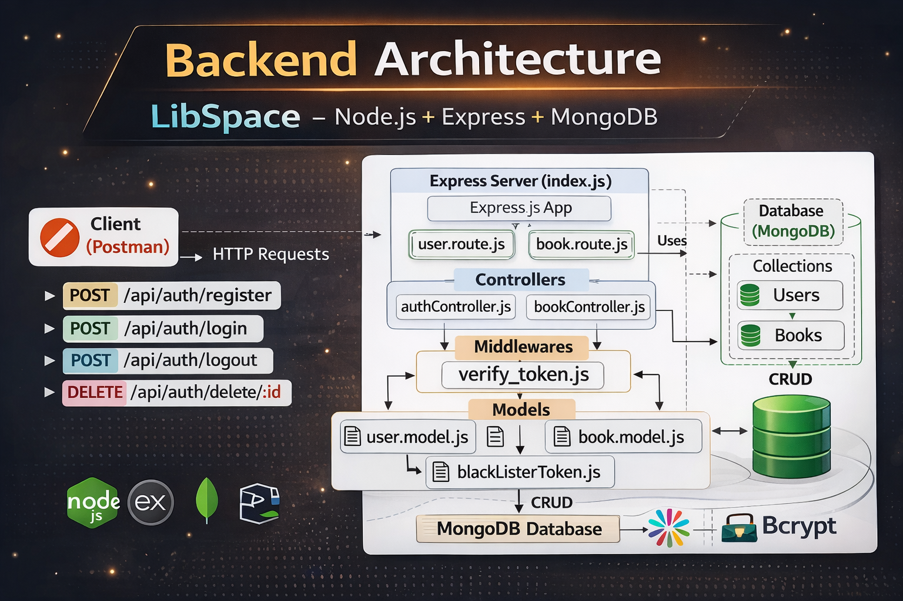
LibSpace follows a layered backend architecture:
1. API Layer (Routes)
2. Business Logic Layer (Controllers)
3. Data Access Layer (Models / Database)
- Node.js + Express Backend
• RESTful API architecture
• JWT authentication middleware
• MVC pattern
• Error handling and validation
- MongoDB Database
• Document based NoSQL storage
• Mongoose ODM for schema modelling
• Two collections: Users and Books
Relationship: One User → Many Books

DATABASE ARCHITECTURE
Users Collection Fields:
- _id
- name
- email
- password (hashed)
- timestamps

Books Collection Fields:
- _id
- title
- author
- url
- userId
- timestamps
Relationship: One User → Many Books
ER DIAGRAM
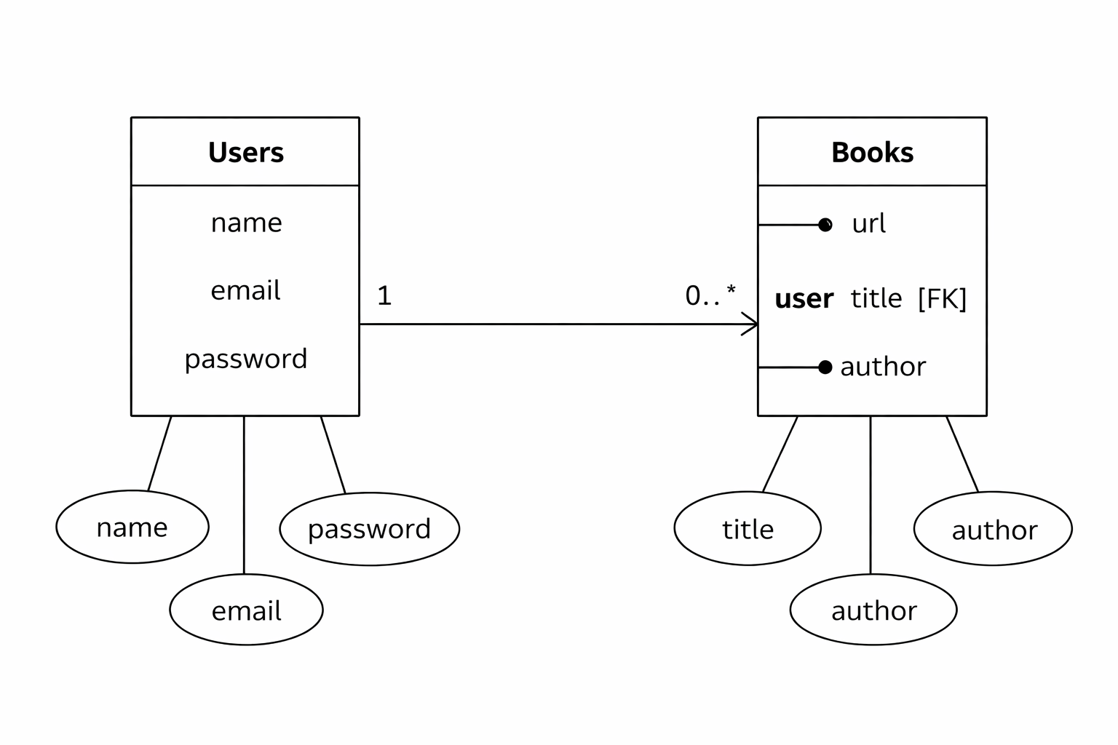

FEATURES
User Authentication
- Registration
- Login
- JWT token verification
- Delete account
Book Management
    - Add book
    - View books
    - Get book by ID
    - Update book
    - Delete book
Security
    - Protected routes
    - Authentication middleware
    - Input validation

ROLES AND RESPONSIBILITIES
User Actions
1. Register account
2. Login with credentials
3. Add new books
4. View books
5. Update book details
6. Delete books
7. Logout securely

PROJECT SETUP AND CONFIGURATION
Folder Structure
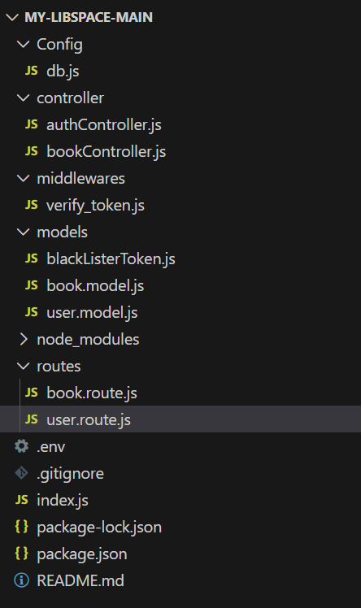

BACKEND DEVELOPMENT
Setup Express Server
Create index.js and add middleware such as express.json() and dotenv.

User Authentication Routes:
- POST /api/auth/register
- POST /api/auth/login
- DELETE /api/auth/delete

Book Routes:
- POST /api/book/add
- GET /api/book
- PUT /api/book/:id
- DELETE /api/book/:id

DATABASE CONFIGURATION
- Install mongoose
- npm install mongoose
- Create database connection using Mongoose: mongoose.connect(process.env.MONGO_URI)

PROJECT EXECUTION
Execution Steps
- Open project folder
- Install dependencies
npm install
- Start server
npm start
- Server message appears:
Server running at PORT 5000
Connected to MongoDB
- Test APIs using: Postman & Thunder Client

OUTPUT SCREENSHOTS
Register API
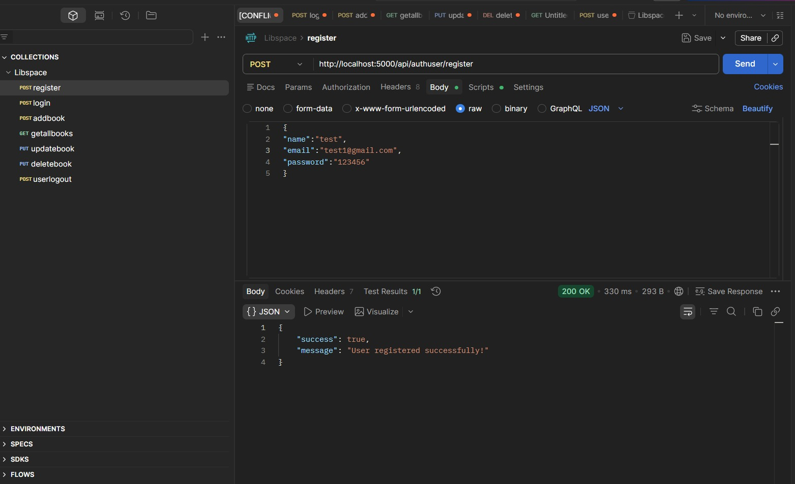

Login API
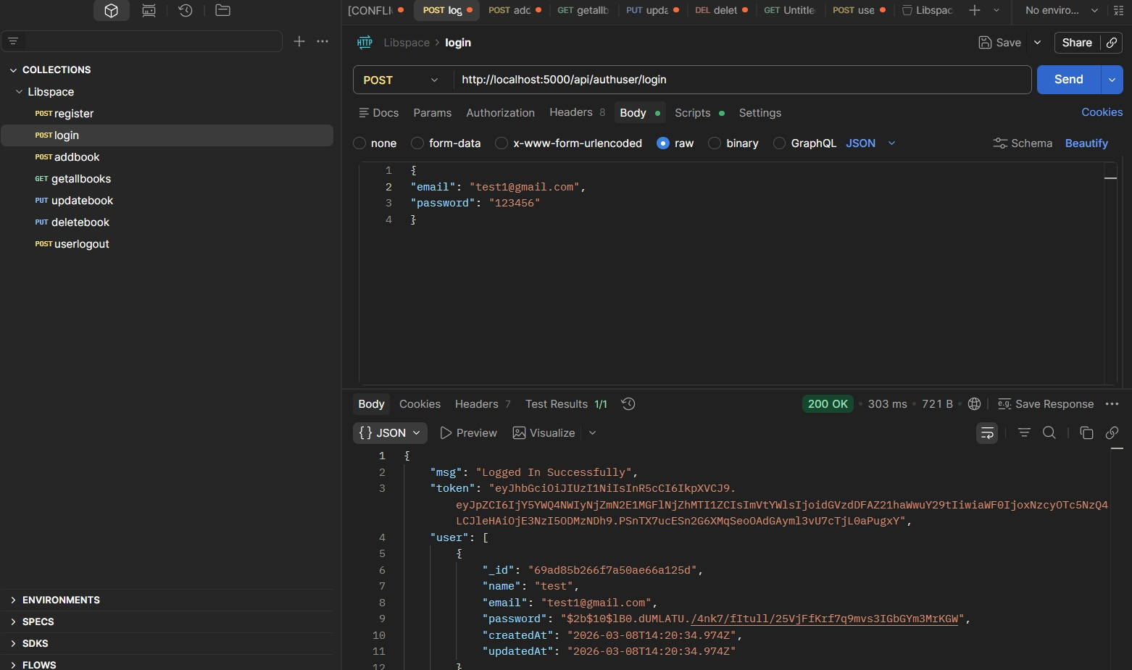

Add Book
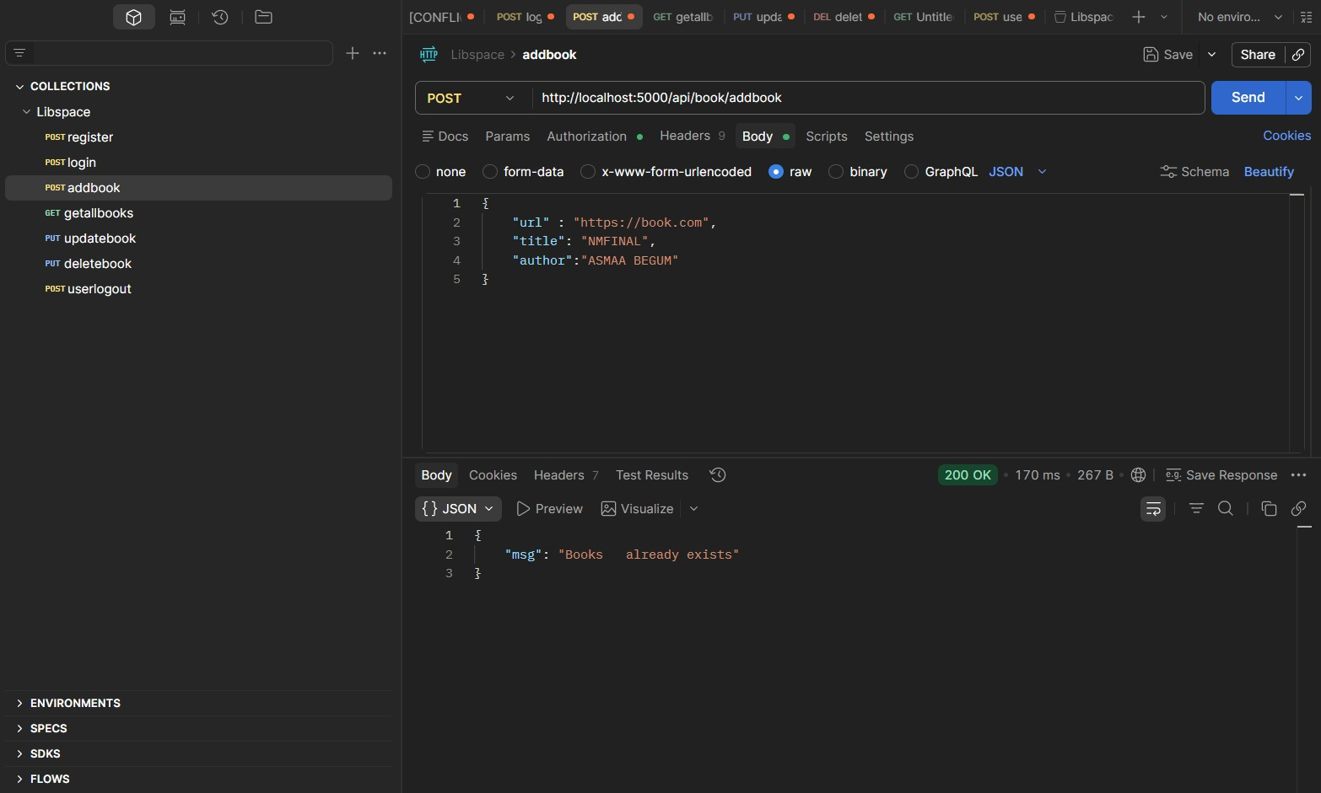

Get Books
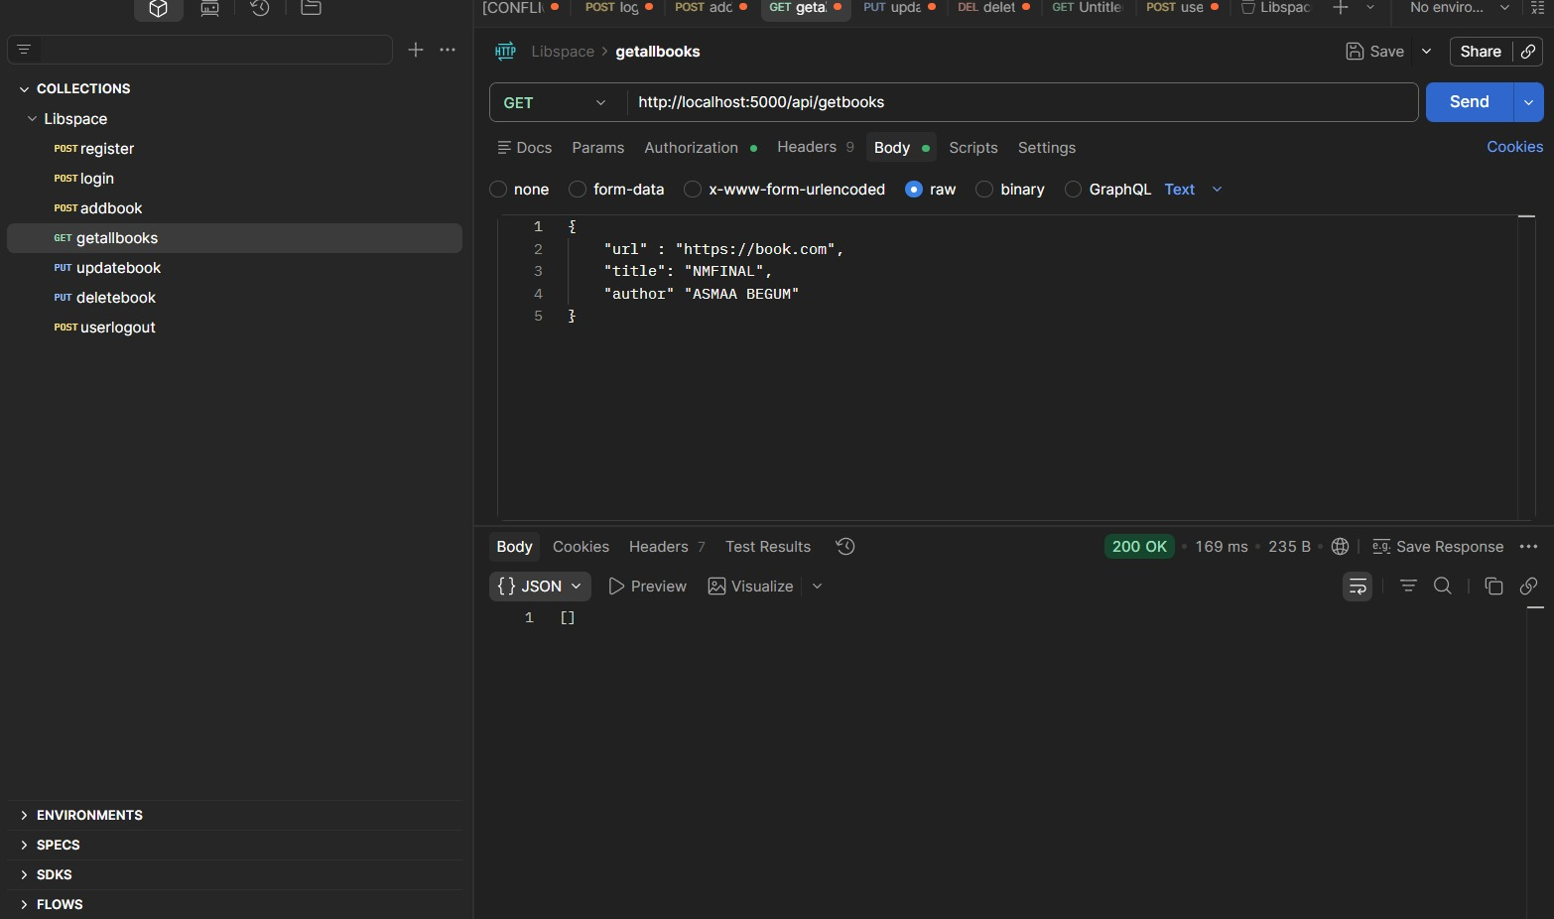

Update Book
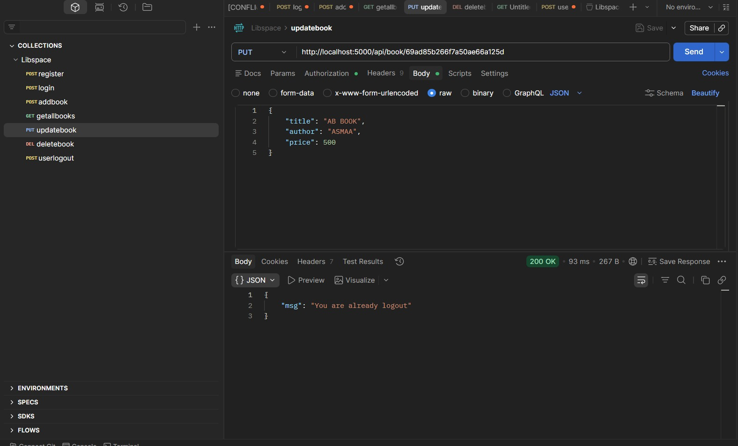

Delete Book
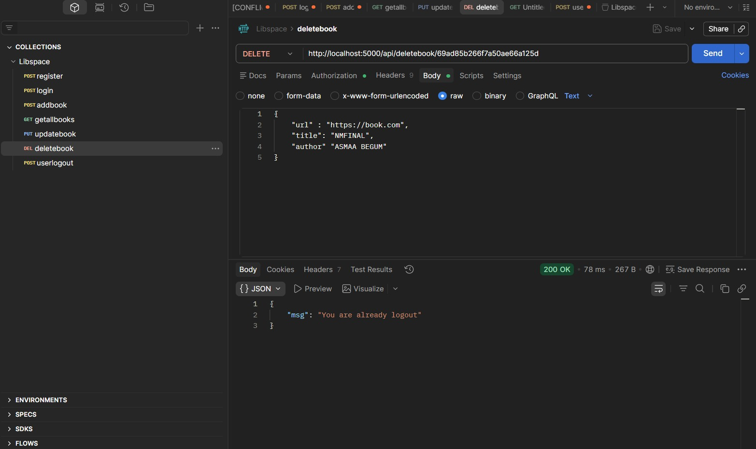

Logout
